***My Target: ______ / 40 or ______ % Complete on the day of the test***

***🖒 🖓 (Circle when your test is handed back)***

**Name: Date Teacher:**

**Task 3 –** In-Class **(History)**

1. Multiple choice, 15 Marks Total
2. Short answer responses 12 Marks Total
3. Validation Short Response16Marks Total

|  |  |
| --- | --- |
| ***Total Mark*** | ***7 %*** |
| ***______ /40*** | **__________** |

**READING TIME – 5 Minutes WORKING TIME – 45 Minutes**

**(Part A) Multiple Choice (______/15 marks Total)**

1. Read the following description and say which person it describes:

*“I make sure the Pharaoh’s orders and wishes are carried out. I meet with the Pharaoh and then see lesser officials to pass on the Pharaoh’s instructions…..”*

1. The Scribe
2. The High Priest
3. The Governor
4. The Vizier
5. What was the purpose of a *shaduf*?
6. To make paper out of papyrus
7. To remove the internal organs of a person during the mummification process
8. To lift water from the Nile River to irrigate fields
9. To plough the fields of barley and wheat
10. How often did the inundation of the Nile occur, leaving behind rich soil?
11. Monthly
12. Yearly
13. Daily
14. Weekly
15. Why were Egyptian Pharaohs different from other powerful rulers?
16. They ruled inside of pyramids
17. They had more influence than other rulers
18. They were believed to be both a god and ruler
19. They were worshipped long after they died
20. How does the mummification process reflect the religious beliefs of ancient Egyptians?
21. It prevents the soul, or ka, from escaping.
22. It was meant to preserve the body for the afterlife.
23. They believed Ra, the sun god, needed a body to inhabit.
24. All of the above.
25. Which ancient Egyptian god is portrayed as a Jackal?
26. Anubis, the god of mummification and the afterlife
27. Ra, the sun god and one of the creators of ancient Egypt
28. Thoth, the god of writing and wisdom
29. Osiris, the god of the underworld
30. Which of the following is in the correct order: from most powerful to least powerful.
31. Pharaoh, vizier, farmers, scribes, nobles
32. Pharaoh, vizier, nobles, soldiers, slaves
33. Pharaoh, nobles, soldier, farmer, scribes
34. Vizier, pharaoh, noble, soldier, scribe
35. Who would the people of Egypt blame if crops did not grow or disease struck?
36. The farmers whose small villages were unclean
37. The mummies whose ka was disturbed
38. The pharaoh
39. The dynasty that was in power
40. Which of the following organs was not removed from the body during mummification?
41. The lungs
42. The brain
43. The intestines
44. The heart
45. The fertile area with rich, dark soil surrounding the Nile River is known as:
    1. Red Land
    2. Black Land
    3. Upper Egypt
    4. Lower Egypt

11. Which king was responsible for uniting upper and lower Egypt?

a. King Buto

b. King Hierakonpolis

c. King Narmer

d. King Raman

12. Mummies were buried with lots of possessions that the person may need for the afterlife. Which of the following was buried with the mummy?

a. food, drink, clothing perfume, furniture, jewellery and amulets

b. amulets, jewellery, furniture, perfume, clothing, hymns

c. prayers, hymns, food, clothing, perfume, amulets

d. All of the above.

13. Ancient Egypt has three seasons, which is the most correct

a. Feret, Shemu, Paket,

b. Aket, Peret, Shemu

c. Shemu, Parket, Feret

d. none of the above

14. The Rosetta stone was found in (select the most correct answer)

a. Rosetta/Rashid

b. Rosetta/Rome

c. Rashid/Alexandra

d. Rosetta/Ciaro

15. Which of the following statement is true

|  |  |
| --- | --- |
| T | F |
|  |  |

a. Egypt has 80 Pyramids, the three most famous are Giza, near Cairo

See next page

**(Part B) Short Answer Response (11 marks in Total)**

1.Describe what the daily life would have been like for one societal group in Ancient Egypt?

(4 marks)

Group One: _________________________________________________________

1. Explain the purpose of mummification in ancient Egypt. (3 marks)

See next page

1. Label the sections in the Great Pyramid. (4 marks)

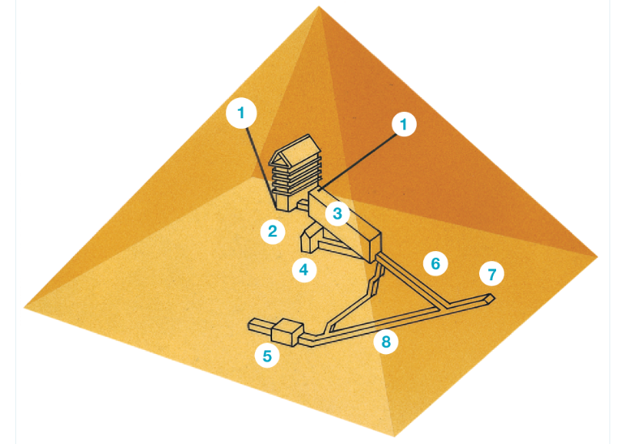

1

2 Pharaoh’s Burial Chamber

7

3.

4

5 False Chamber

8 Descending Corridor

6 Ascending Corridor

**Part c. Validation Section (14 Marks Total)**

*Responses that provide detail, full explanations and examples, where required, will gain a greater amount of the marks offered. Ensure that you read the action words carefully and consider what action the task is intending you to take.*

1. State the name of the significant individual you studied. (1 mark)

___________

1. Outline your individual’s early life. (3 mark)

This task is asking you to consider;

* Where and when the individual was born
* Parents name
* Early influences on their life.

1. Describe the challenges your individual faced in their time. (5 marks)

This task is asking you to consider;

1. What issues/challenges did the individual face?
2. Were the issues/challenges that the individual faced presented by others?
3. Did the individual overcome these challenges? Why/why not?

a.

b.

c.

See next page

1. Explain how your chosen individual is considered significant today. (5 marks)

*This task is asking you to consider;*

1. *What is your individual remembered for?*
2. *What short-term and long-term impacts did your individual have on society?*
3. *What is your individual’s legacy?*

a.

b.

c.

End of Test